

CROWDFUNDING SOFTWARE EVALUATION REPORT



Following is the list of open-source crowd funding platforms which are being evaluated:-

1. Catarse

2. Selfstarter

3. CrowdTiltOpen



**WHAT IS CROWDFUNDING??**

Crowdfunding is basically a service where people from different organisations can interact among themselves. Here some individuals pool money and offer some other resources to some of the projects which are initiated by some different group of individuals.

Crowdfunding is not limited to only a domain. The projects may include creative works, products, non-profit organizations, supporting entrepreneurship, businesses, or donations for a specific purpose (e.g., to pay for a medical procedure).

Usually crowdfunding takes place through an online portal because crowd funding involves a lot of transactions. Also the platforms provide various other services such as media hosting, social networking and also provide contacts to various other contributors to a particular project.



**CATARSE**

This is a open-source crowd funding platform from Brazil for creative projects. Its main goal is with opening the source code is to stimulate the creation of a community of developers around a high-quality crowdfunding platform.

**Requirements:-**

1. Ruby 2.2.2

2. PostGreSQL

3. Git Repo of the app from <https://github.com/catarse/catarse>

4. Apache server

5. Bower package

**Installation Steps:-**

**Ruby 2.2.2 (Ubuntu Trusty Tahr 14.04 LTS)**

1. sudo apt-get update

2. sudo apt-get install git-core curl zlib1g-dev build-essential libssl-dev libreadline-dev libyaml-dev libsqlite3-dev sqlite3 libxml2-dev libxslt1-dev libcurl4-openssl-dev python-software-properties libffi-dev

3.cd

4. git clone git://github.com/sstephenson/rbenv.git .rbenv

5. echo 'export PATH="$HOME/.rbenv/bin:$PATH"' >> ~/.bashrc

6. echo 'eval "$(rbenv init -)"' >> ~/.bashrc

7. exec $SHELL

8. git clone git://github.com/sstephenson/ruby-build.git ~/.rbenv/plugins/ruby-build

9. echo 'export PATH="$HOME/.rbenv/plugins/ruby-build/bin:$PATH"'



>> ~/.bashrc

10. exec $SHELL

11. git clone https://github.com/sstephenson/rbenv-gem-rehash.git ~/.rbenv/plugins/rbenv-gem-rehash

12. rbenv install 2.2.2

13. rbenv global 2.2.2

14. ruby -v

15. echo "gem: --no-ri --no-rdoc" > ~/.gemrc

16. gem install bundler

**Rails**

1. sudo add-apt-repository ppa:chris-lea/node.js

2. sudo apt-get update

3. sudo apt-get install nodejs

4. gem install rails -v 4.2.1

5. rbenv rehash

6. rails -v

# Rails 4.2.1

**PostGreSQL**

1.sudo sh -c "echo 'deb http://apt.postgresql.org/pub/repos/apt/ precise-pgdg main' > /etc/apt/sources.list.d/pgdg.list"

2. wget --quiet -O - http://apt.postgresql.org/pub/repos/apt/ACCC4CF8.asc | sudo apt-key add -

3. sudo apt-get update



4. sudo apt-get install postgresql-common

5. sudo apt-get install postgresql-9.3 libpq-dev

6. sudo -u postgres psql

7. postgres=# \password postgres

**Bower**

1.sudo apt-get install nodejs

2. sudo apt-get install npm

3.sudo npm install bower -g

**Catarse**

1.git clone <https://github.com/catarse/catarse.git>

2. cd catarse

3. cp config/database.sample.yml config/database.yml

4. bundle install

5. bower install

6. rake db:create db:migrate <db:seed>

7. rails server

Setup is complete and you can run the project on http://localhost:3000

**Sample Sites using Catarse:-**

**Brazil**

* Catarse: [http://catarse.me](http://catarse.me/)
* Vamos Agir: [http://www.vamosagir.com](http://www.vamosagir.com/)



* Koper: [http://www.koper.com.br](http://www.koper.com.br/)
* Impulso: [http://www.impulso.org.br](http://www.impulso.org.br/)
* Nos.vc: [http://www.nos.vc](http://www.nos.vc/)
* Fomente Cultura: [http://www.fomentecultura.com.br](http://www.fomentecultura.com.br/)

# **Worldwide**

* ProduceRun: [www.producerun.com](http://www.producerun.com/)
* KrowdKidz: <http://www.krowdkidz.com/>
* Neighbor.ly: <http://www.neighbor.ly/>
* MedStartr: <http://www.medstartr.com/>
* Lincipit: <http://www.lincipit.com/>
* Fund Weaver: <http://www.fundweaver.com/>
* Crowdfunded: <http://crowdfunded.dk/>
* UrabanKIT: <http://urbank.it/en>
* Nobleza Obliga: [http://noblezaobliga.com](http://noblezaobliga.com/)



**Features:-**

1. This project is not limited to a particular domain like many other crowdfunding platforms do. For eg :- ArtistShare crowd funding platform only supports music etc.

2. This project is open-source and so this is a advantage that we can modify the codes according to our own needs.

3. Its a ruby on rails stack

4.It supports many payment gateways like MOIP, Paypal and WePay. Also if we have created our own payment gateway then it can also be easily integrated by contacting the catarse community.

**Pros:-**

1. Since this is a ruby on rails stack so it uses some advanced technology.

2. It uses advanced versions of ruby so it will be more advanced as compared to other open source crowdfunding platforms.

3. It supports many great payment gateways and we can also integrate our own payment gateway

4. There is a community which is maintaining it as it is the biggest crowdfunding platform of Brazil. We can contact them at:-

(<https://www.pivotaltracker.com/projects/427075>)

<http://groups.google.com/group/catarse-dev>



**Cons:-**

1. This crowfunding platform only supports Brazillian language as of now but according to thier Github updates they are currently working on releasing it on international languages also.

2. Little difficult to setup in windows environment as many steps are not populated.

**Extensiblity:-**

This platform is very good and I think this can be used widely as many websites have deployed it. Also it is more technically advanced as it uses latest versions of ruby.

According to me, we can wait till it is launched in English and then we can go with this platform as its UI and services provided are up to the mark as compared to other open source crowd funding platforms.

**Installation Time**

Since this was my first hands on with ruby on rails so it took me 2 days to install them. If you have some pre-requisite on ruby on rails it will take very less.



**SCREENSHOTS (Running on localhost:3000)**

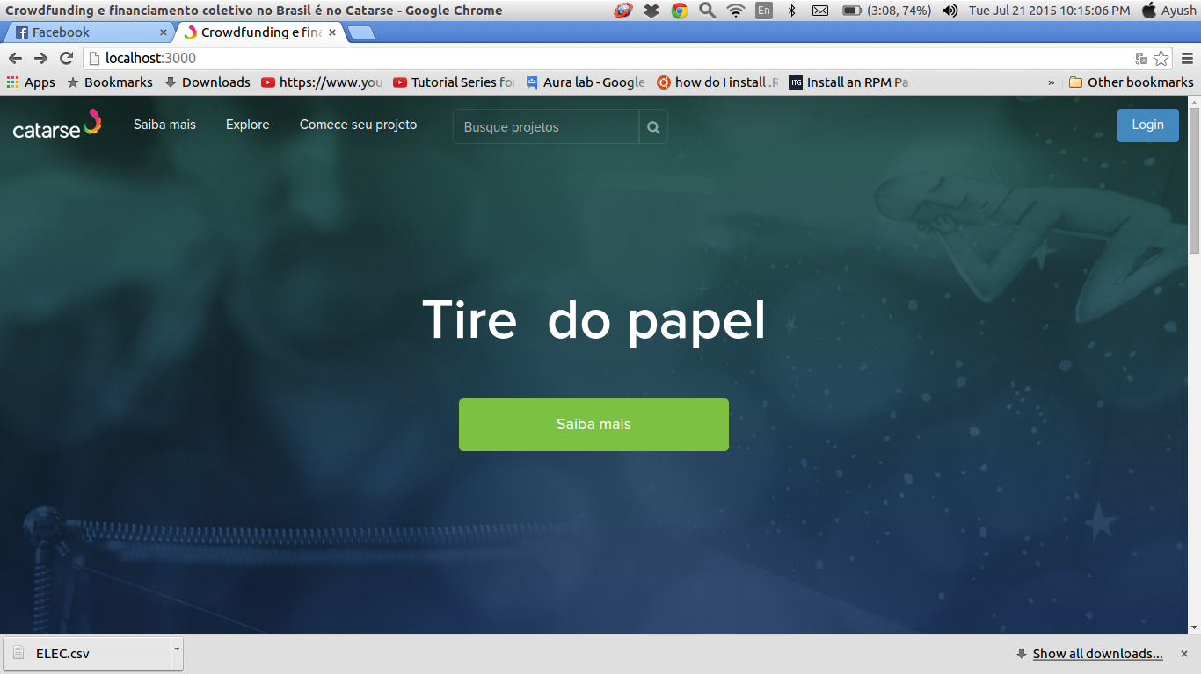

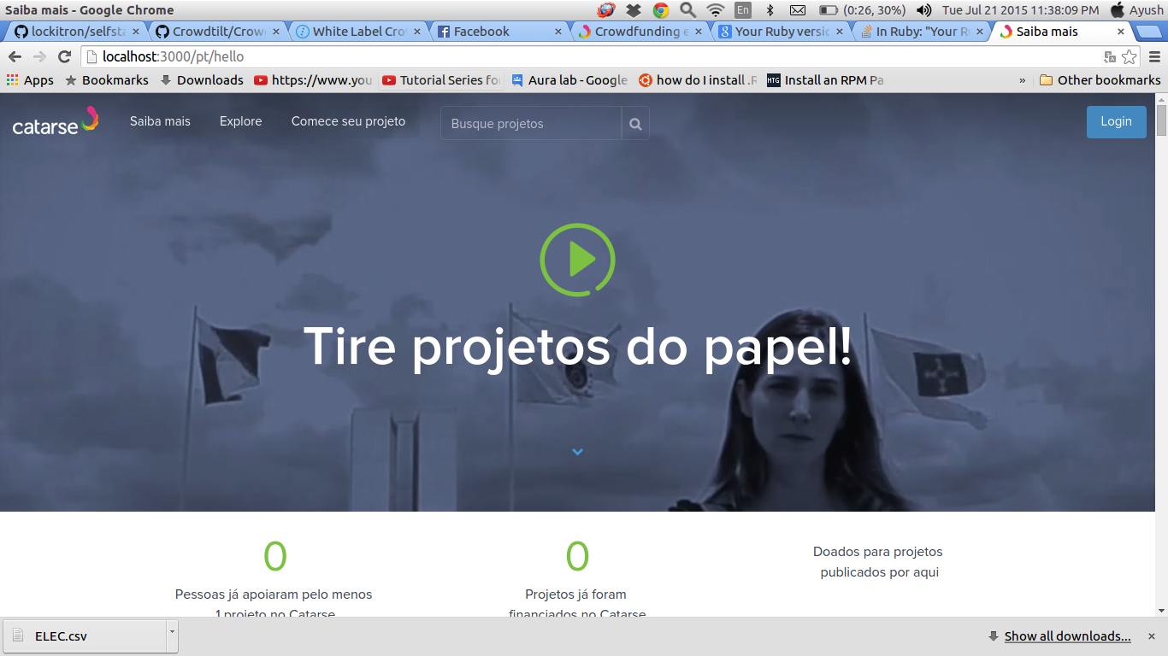





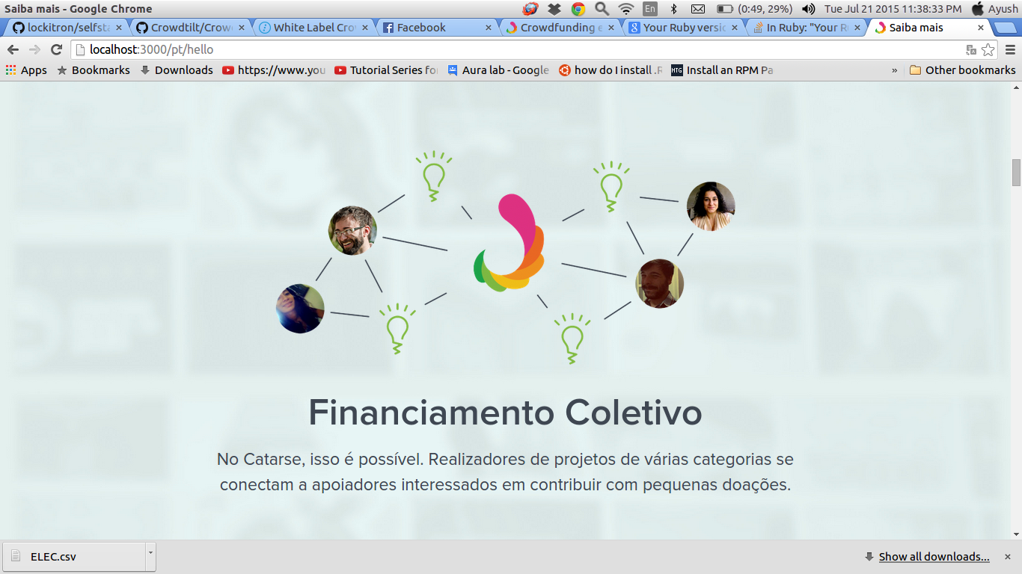



**Self Starter**

This is an open-source crowdfunding platform that supports everything and we can develop and customise the app according to what we want. Selfstarter is an open source starting point for building our own ad-hoc crowdfunding site. This was built by Lockitron when he was turned down by Kickstarter which is now a very big but a paid crowdfunding platform.

**Requirements:-**

1. Apache server

2. Ruby version 1.9.3. or higher ( I used ruby 2.0.0)

3. Github repo from <https://github.com/lockitron/selfstarter>

4. Heroku Belt (For Deployment)

**Features:-**

1. As compared to Kickstarter with Selfstarter, we can link directly to the website press and commentary linking to our project. So we don't lose out on the long tail of traffic with regard to [SEO](http://www.entrepreneur.com/seo/index.html). It is much more directly funding us as a company as opposed to just funding a project.

2. The project is open source and all the codes are present on github :- <https://github.com/lockitron/selfstarter>. So we can get all the codes and customise them according to our needs.

3. The initial User Interface is very simple so that users can



modify the frontend according to thier needs easily.

4. Its a ruby on rails stack

5. It supports the great Amazon payments option. Also we can integrate our own payment gateway.

**Pros**

1. Its open source so we can easily fork the github repository and customise the code accordingly.

2. It uses Amazon Payments for payments. It can use [Stripe](https://stripe.com/) or [WePay](https://www.wepay.com/). It used Kickstarter's awesome amazon_flex_pay gem.

3. It collect multi-use tokens from customers with Amazon Payments - this lets it collect payment information without charging the customer until they are ready to ship.

4. It doesn't come with any authentication, administration, mailers or analytics tools.It recommend adding a basic set of these so that we can message backers and manage orders.

5.There is a payment options component that allows us to define different packages or levels for people to puchase/support at. We can turn it on and off with a configuration setting.

6. Its user inteface is very simple so we can modify its fonts, colors, CSS and every basic functionality of the app according to our own needs.

7. procfile included so can be easily deployed on Heroku

8.Kickstarter encountered a lot of problems because products weren't delivering and people wanted their money back. Selfstarter gives you the flexibility to say, "We can take money up front, or we can wait and take



money when the product is shipped." It shifts the risk away from the backers and onto the project creators.

9. Setting up on the system is easy as compared to catarse.

**Cons**

1.Selfstarter is a skeletal framework. It's a starting point. It is not a crowdfunding website-in-a-box per se. It doesn't have any capability to send update e-mails to keep backers posted about the project. There is no dashboard where you can easily fix errors that come up or switch people's addresses. It really does need a fair amount of customization and development.

2. It uses a little old version of Ruby (2.0.0) as compared to the newest version Ruby (2.2.2) used by catarse.

**Installation**

**Ruby (2.0.0) (UBUNTU 14.04 Trusty Tahr)**

1. sudo su

2.wget <https://cache.ruby-lang.org/pub/ruby/2.0/ruby-2.0.0-p645.tar.gz>

3. tar -xvf ruby-2.0.0-p645.tar.gz

4. cd ruby-2.0.0-p645

5. ./configure

6. make

7. make test

8. make install



**Selfstarter**

1.git clone https://github.com/lockitron/selfstarter.git

2. cd selfstarter

3. gem install bundler

4. bundle install –without production

5. rake <db:migrate>

6. rake <db:seed>

7. rails s

It will start on [http://localhost:3000](http://localhost:3000/)

**CUSTOMIZING**

**To change around the product name, tweet text, and more, open this file:**

config/settings.yml

**To change around the colors and fonts, open this file:**

app/assets/stylesheets/variables.css.scss

**To dive into the code, open this file:**

app/controllers/preorder_controller.rb

**DEPLOYING TO PRODUCTION**

It recommend using Heroku, and it even include a Procfile for us. All we need to do is first install the [Heroku Toolbelt](https://toolbelt.heroku.com/) and then run:

1. heroku create

2. git push heroku master



3. heroku run rake db:migrate

4. heroku open

**Extensiblity**

Since this app uses amazon payments and its UI is quite simple we can deploy it only on a condition that for this to deploy we need to work a lot. Since this is a skeletal version so we need to add the full fuctionality like authenticity etc.

I think we can deploy it only if we want only basic features of crowdfunding platforms to work. If we want to go for advanced versions then we need to work a lot harder to get it going.

**Installation Time**

This took me just 3 hours to install.



**SCREENSHOTS (Running on localhost:3000)**

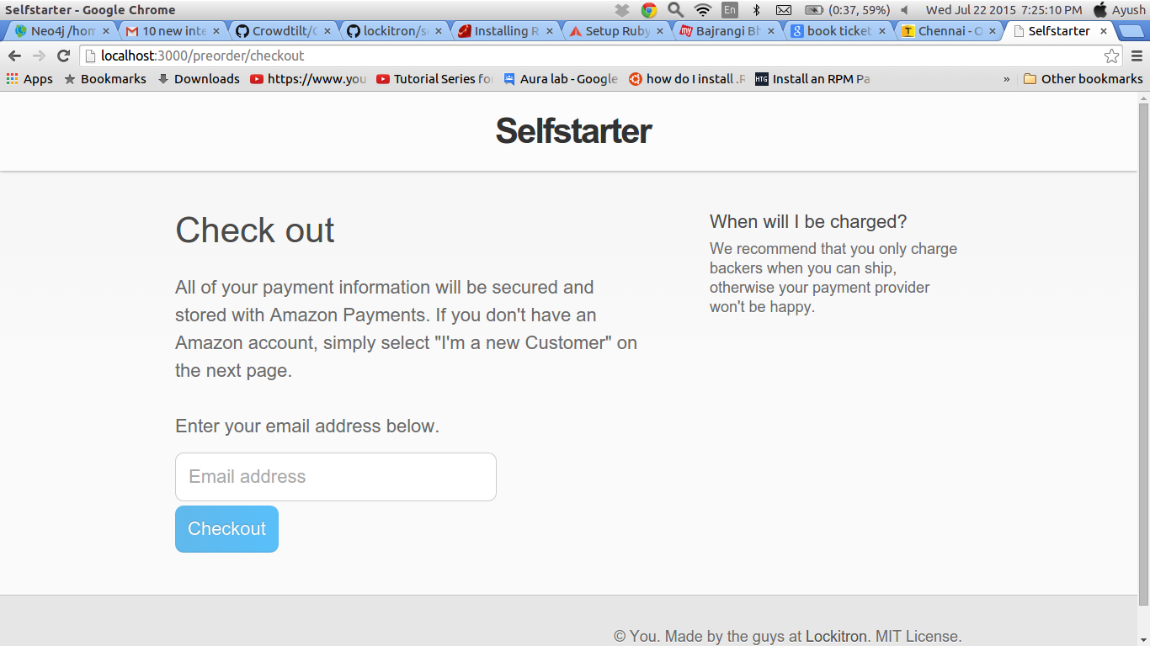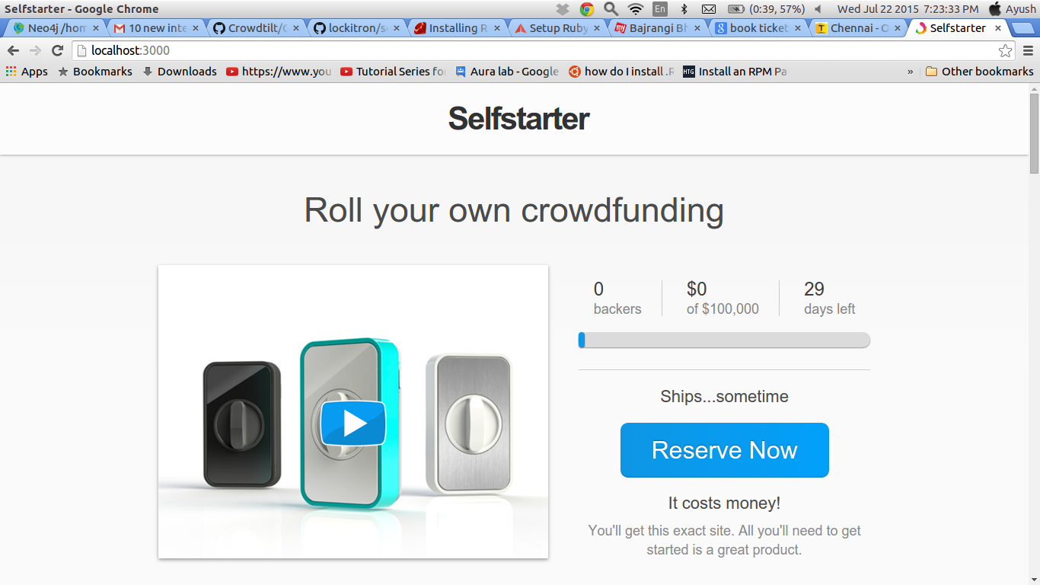



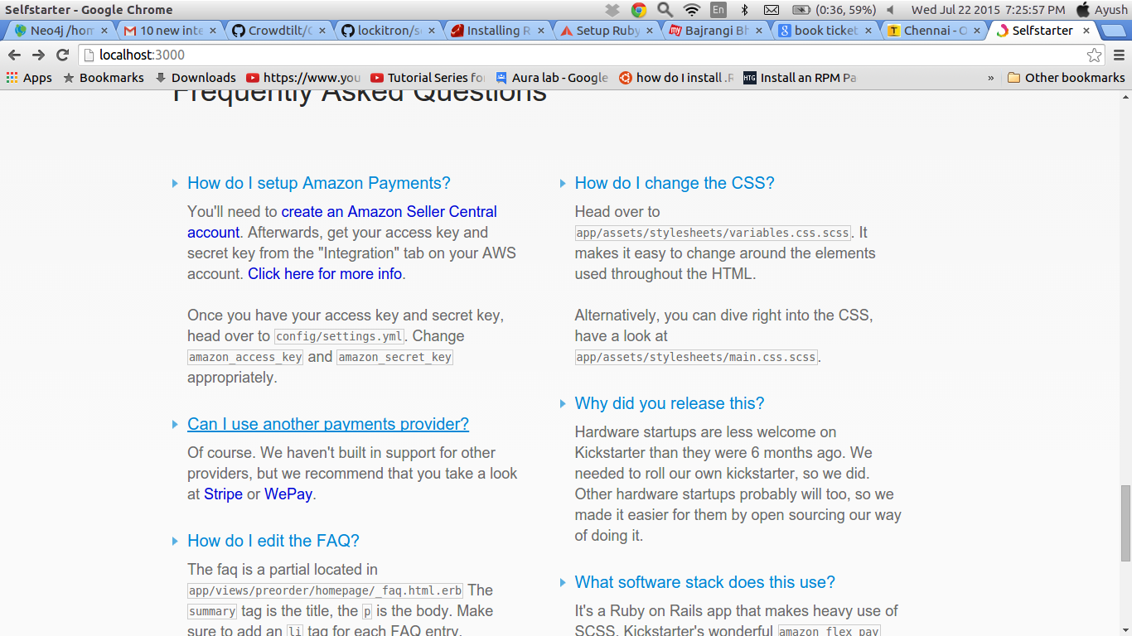

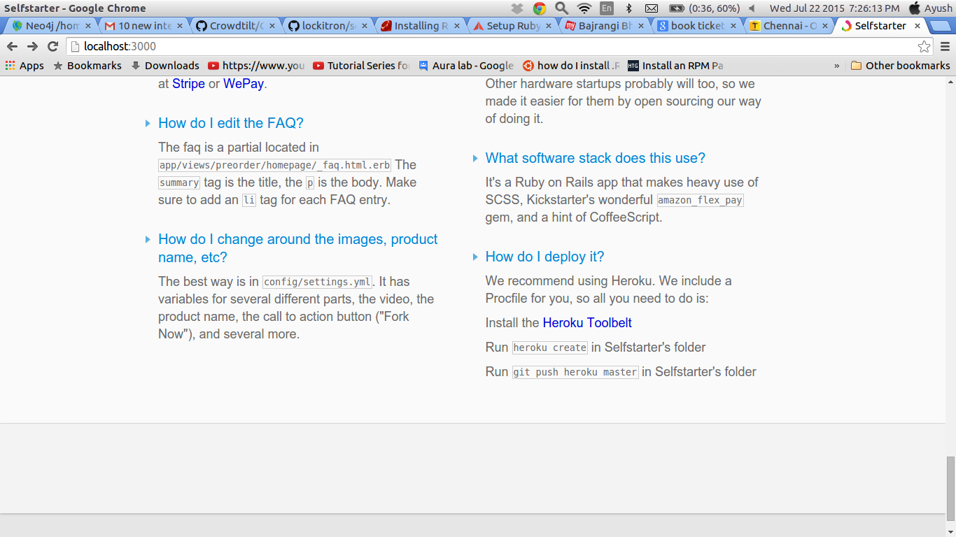

**CROWD TILT OPEN**

Crowd Tilt Open is an open source crowd funding platform which supports free web hosting with our domain itself. This product, [previously called Crowdhoster](http://techcrunch.com/2013/08/22/crowdtilt-launches-crowdhoster-a-wordpress-for-crowdfunding-to-let-anyone-create-and-customize-their-own-campaign/), has been rebranded and relaunched with several more features designed for those who want to better customize and self-host their own fundraising campaigns.

**Requirements:-**

1. Apache Server

2.RVM, ruby 1.9.3, and the Rails gem

3. Homebrew package

4. Github

5. Postgres

6.ImageMagick

**Installation (Ubuntu 14.04 Trusty Tahr)**

**Homebrew**

ruby -e "$(curl -fsSL <https://raw.github.com/Homebrew/homebrew/go/install>)"

**Git**

brew install git

**Ruby**

1.sudo su

2.wget <https://cache.ruby-lang.org/pub/ruby/1.9/ruby-1.9.3-p551.tar.gz>

2. cd ruby-1.9.3-p551



3. ./configure

4. make

5. make test

6. make install

**CrowdTiltOpen**

1. git clone <https://github.com/Crowdtilt/CrowdtiltOpen>

2. cd CrowdtiltOpen

3. sudo gem install bundler

4. bundle install

5. cp .env.example .env

6. foreman run rake secret

7. foreman run rake secret (Run 2nd time to get 2nd access token)

8. nano .env

9. Change values of

SECRET_TOKEN

DEVISE_SECRET_KEY

10. foreman run rake <db:create>

11 foreman run rake <db:migrate>

12. foreman start

13. foreman run rails c

Your server will start at <http://0.0.0.0:5000/>



**Deploying to Heroku**

1. heroku create {APP NAME}

2. heroku plugins:install git://github.com/ddollar/heroku-config.git

3. heroku config:push

4. git push heroku master

5. heroku run rake <db:migrate>

6. heroku open

7. heroku addons:add papertrail:choklad

**Features**

1. This website has pre-existing themes like bootstrap has its some themes. So we can use their themes and modify them like adding icons, changing CSS, changing colors etc.

2. On this website we can use our own domain i.e this website gets integrated with the cross domains.

3. It is easy to launch as it has its own admin dashboard and its tools. So we do not require to code for such tools.

4. This website supports multiple fund raising campaigns or pre-sale campaigns simultaneously.

5. They have thier own documentation and video tutorials so a beginner can also start implementing it as faster as he can.

6. Credit card processing is easy. The platform has its own tilt api which can be integrated with our website. So this website will handle all credit card processing.

7. All international cards can be accepted on this



platform.

8. If we want to increase our business we can give discounts by giving our customers with the promo codes.

9. Its open-source but we have to pay a small fee on transactions for a successful campaign.

10.We can launch our new campaign very fast on this platform as it has many in-bulit functionalities so we have to code very less.

11. They have a wide support community on [questions@tilt.com](mailto:questions@tilt.com).

12. This platform provides slack channel integration. Slack is a platform where coders or developers can communicate among themselves.

**Pros**

1.They will handle payment processing, promo codes, referral programs, refunds, emails confirmations and more, letting us to focus on our goal: selling our product.

2. We have full control on the front-end part so we can modify how our website looks.

3. If any person is a beginner and he does'nt know HTML, CSS he canmake use of the themes which are present on this platform to host his website.

4.We dont have to change the domain of the website. This platform provides the functionality to integrate with our domain.

5. Also since it provides Slack integration we can provide the users a more powerful interaction medium as slack is the best for communication purposes among the



financer and the developer.

6. It provides a functionality of integrating third party components.

7. The tool offers an expanded feature set which includes recurring billing, direct payments (Visa, MasterCard, Discover, Amex), full customization or a choiceIt from provided themes, analytics integration (e.g. Google, AdRoll, Optimizely, etc.), reward tiers, no time limitations, PCI compliance, support for non-profits soliciting donations, multiple campaigns, and as, noted above, bitcoin integration.

8. It has its own community help at [questions@tilt.com](mailto:questions@tilt.com)

**Cons:-**

1. On each successful campaign we have to pay a small fee to this crowdfunding platform.

2. This platform uses a very old version of ruby i.e. 1.9.3-p551 which is very old so it may not be that technically advanced.

3. Till now it takes only US accounts but if we give them the project idea they will allow us for our country also.

4. Installation is quite difficult as compared to others.

**Extensiblity**

This platform is a very good platform for beginners as well as pros as it has many functionalities free of cost which are only provided by paid versions of crowdfunding platforms like Kickstarter. It also controls the backend processing so that we can just focus on the frontend and do not have to worry on the backend.

**Installation Time**

This took me 1 day to install as it was using some foreman gem which was a bit difficult to set up.



This platform can be implemented just now as it has a very wide and good functionalities but only problem is that we have to pay them a small amount which they have not specified how much so we have to beware of that. Otherwise it can be implemented by a beginner itself.



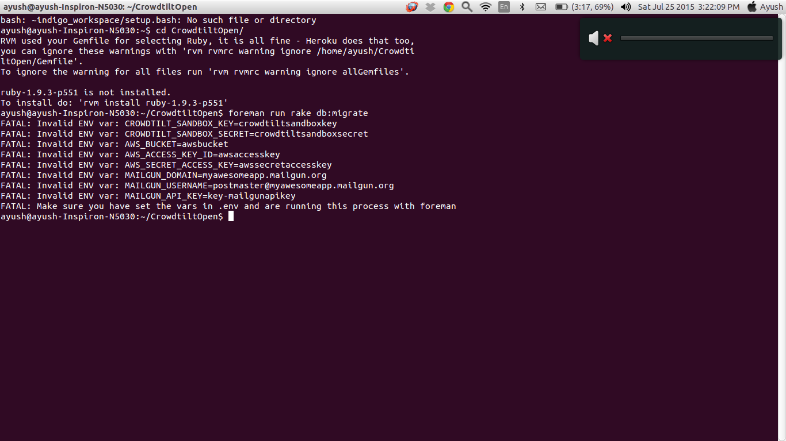

**Screenshots**

I have installed the CrowdTiltOpen but it seems that it cannot be set locally without specifying the values of these variables. Once the variables are set then it can be set.

To set variables:-

run nano .env

Change the variables and press Ctrl+X and Enter.

After it is done run the following commands:-

1. foreman run rake <db:migrate>

2. foreman start

3. foreman run rails c



Below are the screenshots from the original website:-

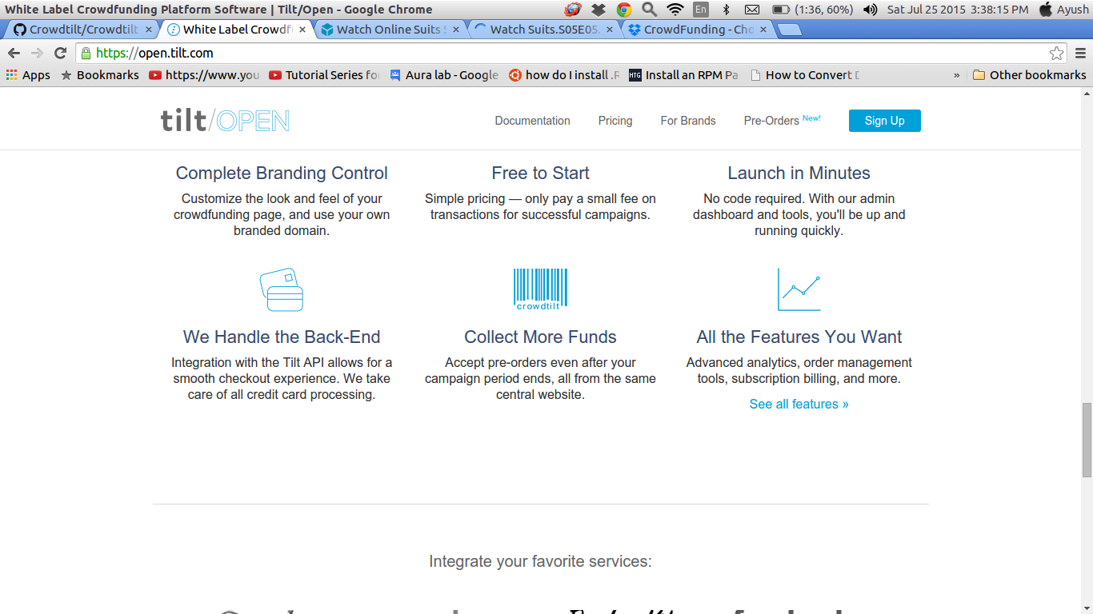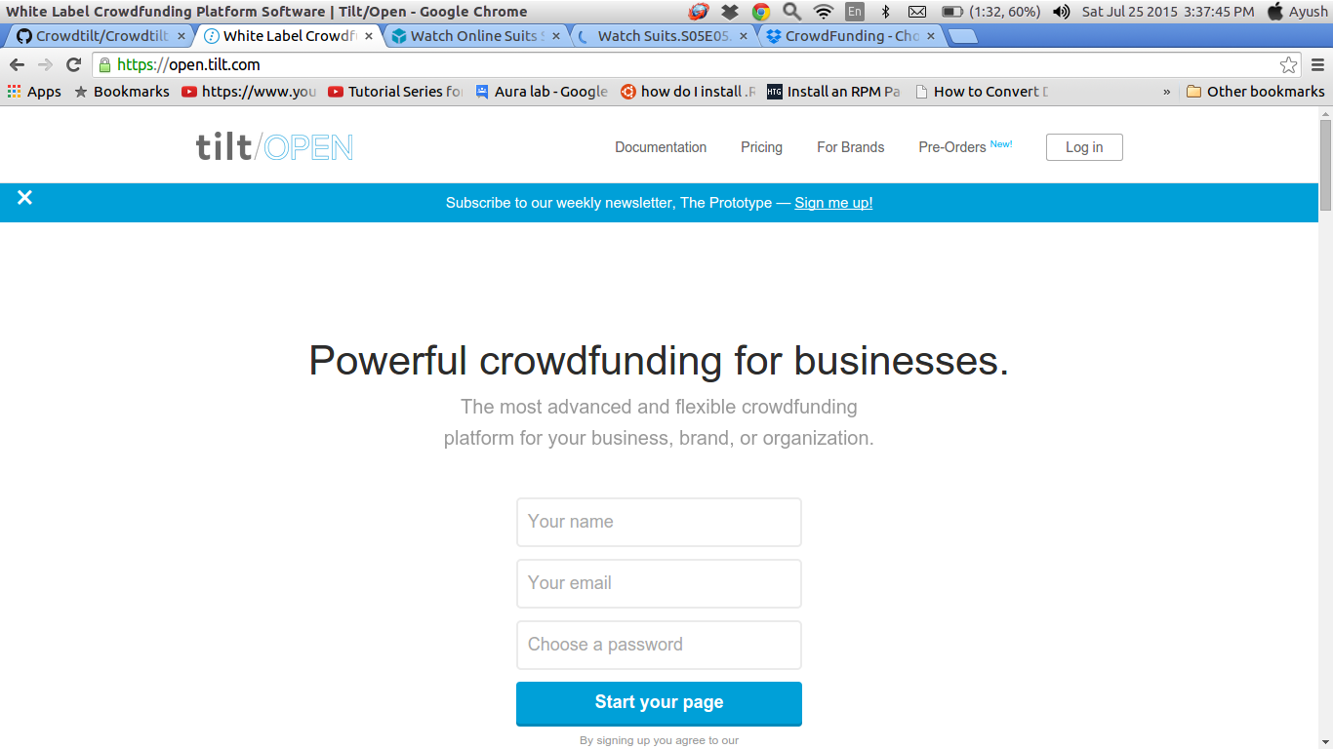



**Conclusion**

So, In the end I will say every crowdfunding platform has its own pros and cons but it depends on the requirement of the clients how much support they want. All the 3 are equally good and they can be used in either ways depending on the requirements.